**1. Introduction:**

**1.1 Background**

New Zealand is a small country with a population of roughly 4,951,500 consisting of two major islands, a north island and south island. The populations of the two Islands are over 3.7 million for the north island and over 1.1 million for the south island.

**1.2 Problem**

If one was to open a Mexican restaurant in New Zealand where might a suitable place be based on population? Would it be in the north or south Island? The north Island has a larger population than the south, and two of the most populous cities so those may be good candidates. The data will help us decide.

**1.3 Interest**

Interested and aspiring restaurateurs may want to know where their chances will be best to open a Mexican restaurant. One of the two major cities in the north island of New Zealand, Wellington and Auckland, may be one of the better options considering they are 1st and 3rd largest in the country, both located in the most populous island? We will try and make a decision based on population and the number of restaurants

**2. Data**

**2.1 Data Sources**

The data being used in this analysis will be from the Foursquare api, Data New Zealand, and wikipedia. There are some missing values in the data set but the longitude and latitude of the locations are still there so we will keep them.

3. Methodology:

**3.1 Collecting Data**

Data about population distribution within New Zealand needs to be analyzed to determine if a population may be large enough to support a restaurant. So we will need to collect and analyse this data first.

Growth rate of the cities is also a determining factor for a potential location so it will be analysed as well. A city with a declining or stagnating population may be a poor choice at best for a restaurant, as customers will dwindle, or at the very best leave no room for expansion.

Data was collected for restaurant locations in Auckland and Wellington using the Foursquare API. We will need to provide the api with the type of restaurant to search for and the longitude and latitude of the center of each city with the search radius desired.

There does seem to be some discrepancy between the foursquare api results and simply going to the Foursquare website and searching for Mexican restaurants. Some of this may be due to the website searching in the entire city, or searching the entire city and adding nearby areas. Our search is from the center of each city, Auckland, and New Zealand, with a search radius of 10 kilometers.

The results from each API request will need to be normalized, and turned into a pandas data frame for further analysis, and to use it for the maps that will be created later.

**3.2 Visualizing the data**

Bar charts were created so one can more easily see the difference between the different regions when it comes to population and growth rate.

Maps were created for each city so one can see a visual representation of each city. This will help in knowing where limitations are that data alone will not. Examples could be locations where it is evident that a restaurant can not be opened, waterways, national parks, etc. It can also show where a restaurant might be opened, for instance between other restaurants where there is a large gap.

Restaurants were plotted on the maps for Auckland and Wellington to show visually where the restaurants are.

Postal zones were going to be used for further analysis but a data set for this information is not readily available and was later determined to be unnecessary, as one can see in the results section and the maps where locations are plotted.

Each data set created for Auckland and Wellington had a total of 14 and 4 which were used to plot their locations on a map. The results of which are discussed in the results section.

**4. Results**

Analyzing the data leads the choice of restaurant location to Auckland. With approximately ¾ of New Zealand's population living in the north Island, it seems logical that further analyses was directed there. Within the North Island, Wellington and Auckland are the largest cities, as one can see in the Population by Region graph, but Aucklands growth surpasess the growth of Wellington in both natural increase and migration. This means that Auckland’s potential customer base is larger and faster growing at the same time.

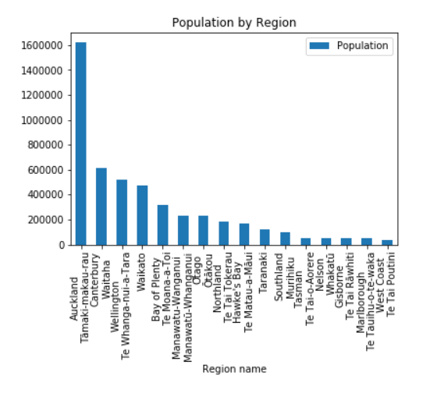

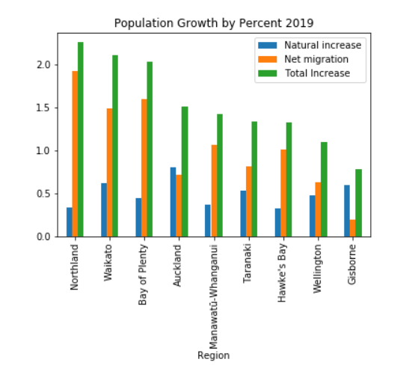

After plotting the data frame built from the Foursquare API results on a map It was clear that a majority of the restaurants in Auckland occur mainly in the City Business District or CBD. There are gaps between similar restaurants which can be filled by other similar restaurants. This will allow potential customers who are between two or more restaurants other than the one being opened,to potentially choose one in the middle if it is an option. Or if the others are full or the wait time is too long, the potential restaurant being opened could also be an option.

**5. Discussion**

Given the data that can be collected at this time, it appears that Auckland would be a suitable candidate for a mexican restaurant. With locations near or in Kingsland, Mount Eden, or Remuera seeming to be suitable locations, as they are in, or near Auckland CBD and between other Mexican restaurants in a populated area.

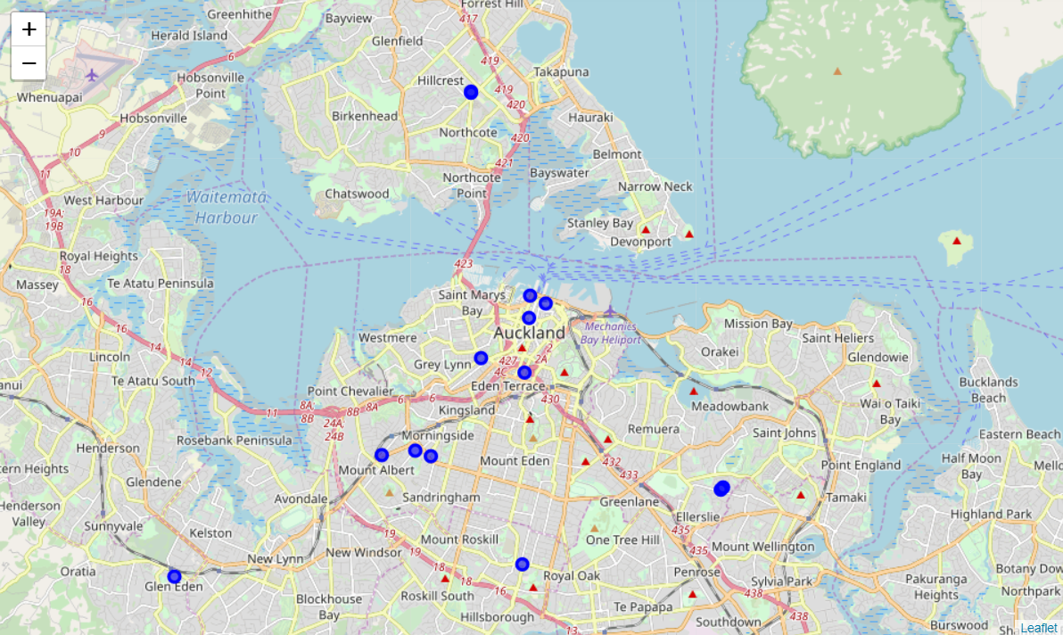

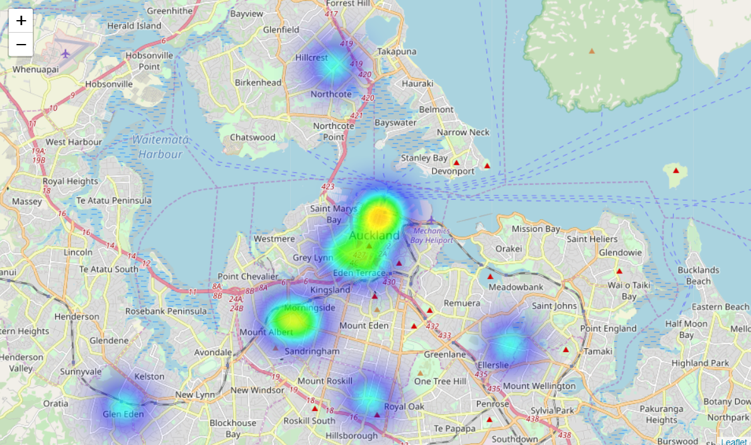

References:

[www.stats.govt.nz/topics/population](https://www.stats.govt.nz/topics/population)

Foursquare API

Wikipedia